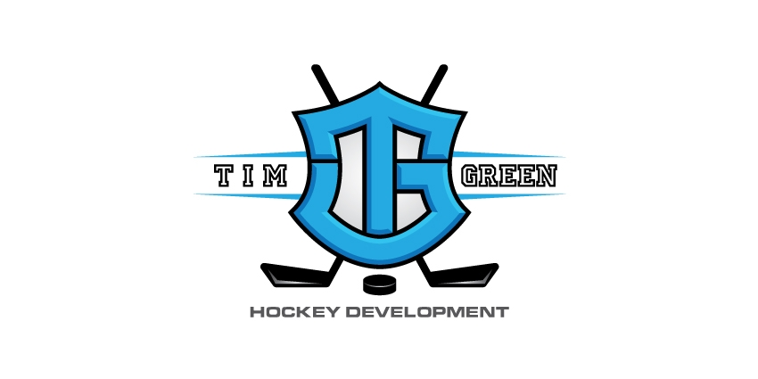
TG Hockey Summer Hockey Camps 2017
Timgreenhockey.com

Week 1 August 1st – 5th (Tuesday – Saturday)

Initiation Skills and Games. $209.00
Novice Skill Development & 3v3. $385.00
Atom Skill Development & 3v3. $385.00
Peewee Skill Development & 3v3. $385.00
Bantam Skill Development & 3v3. $385.00
Midget/Jr. Elite Prep Camp. $160.00

Week 2 August 7th – 11th (Monday – Friday)

Novice Power Skating. $209.00
Novice Super Skills & Small Area Games. $209.00
Atom Power Skating. $209.00
Atom Super Skills & Small Area Games. $209.00
Peewee Power Skating. $209.00
Peewee Super Skills & Small Area Games. $209.00
Bantam Body Contact. $209.00
Bantam Super Skills & Small Area Games. $209.00
Midget/Jr. Elite Prep Camp. $160.00

To register for a camp, go to please visit our camp sign up page or contact Tim Green at 780-563-1010 / timgreen34@gmail.com

Our Vision: For every player to have the opportunity to participate develop and achieve success in a positive and enjoyable atmosphere.

