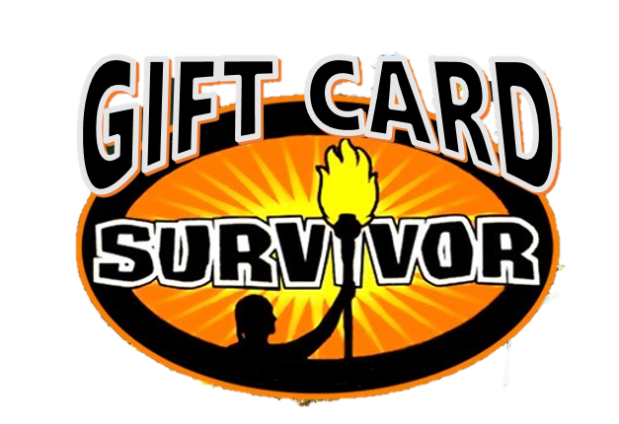

TEAM NAME: **__________________________________________________________**

Player #1: **_____________________________________________________________**

Email: **____________________________** Phone# **_______________________**

Player #2: **_____________________________________________________________**

Email: **____________________________** Phone# **_______________________**

Player #3: **_____________________________________________________________**

Email: **____________________________** Phone# **_______________________**

Player #4: **_____________________________________________________________**

Email: **____________________________** Phone# **_______________________**

Player #5: **_____________________________________________________________**

Email: **____________________________** Phone# **_______________________**

Player #6: **_____________________________________________________________**

Email: **____________________________** Phone# **_______________________**

**Raffle license # 479372**

**ENTRY FORM**

**GIFT CARD SURVIVOR OFFICIAL RULES**

- Each person you recruit will be a member of a 6-person team. Each member of the team donates $25 to participate as well as a $25 gift card of their choice. Collect $50 and buy the gift card for the people on your team that are out of town or too busy! If you have extra people that do not form a full team – no worries – we will bundle up teams for you!

- Teams can enter by printing out the entry form from our website ([www.vermilionminorhockey.com](http://www.vermilionminorhockey.com)) or on our Facebook page. Entries will be accepted until November 24th, 2017 with drop off at the Vermilion Stadium on November 22nd & 23rd from 5 – 9pm both evenings. Participants are responsible for completing the entry form, collecting the cash & gift cards before dropping off.

- Starting November 25th, individual names will be eliminated but as long as 1 team member from your team is still in the draw, your team is safe! Once all 6 names have been pulled, your team is eliminated. Within 7 days everyone will be eliminated but the final teams.

- We will be sending out a daily email with the list of people who are eliminated. As well as posting on our GIFT CARD Survivor Facebook Group.

- The final draw will take place on December 1st. Prizes will be dependent on how many teams are entered. For example:

66 teams enter = top 10 teams will receive a share of the gift cards with the top team sharing $6000 worth of gift cards!!!

- Participants need to be 18 years of age or older.

- You do not need to be a member of VMHA to participate!! Everyone is welcome…the more, the merrier!!

- Cash and cheques (made out to Vermilion Minor Hockey Association) for entry fees only.

- You can be on multiple teams and so can your recruits. The more teams you are on, the better your odds of winning!!

- Have fun & may the best SURVIVOR TEAM win!!